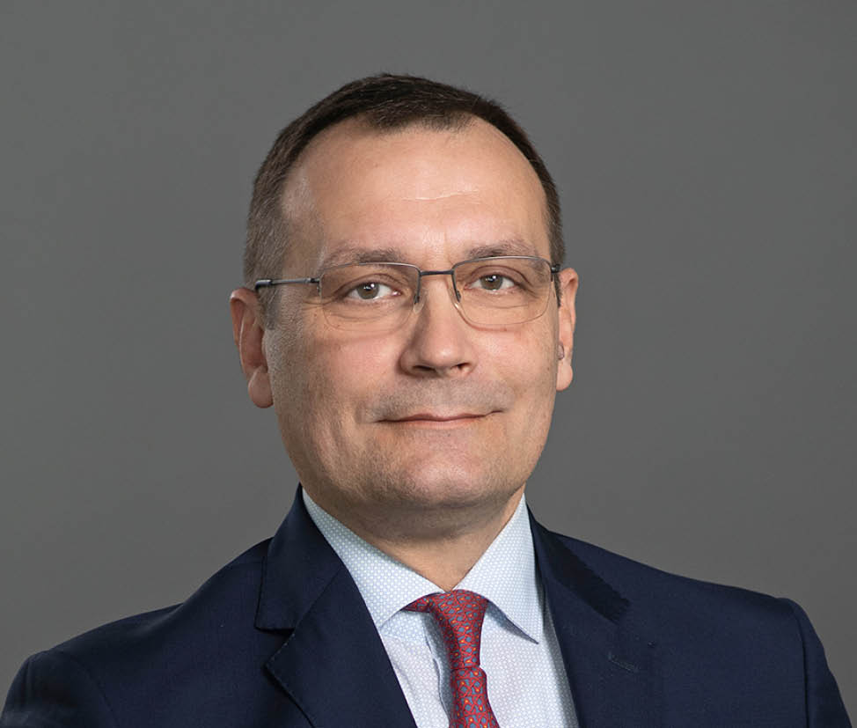
Yuriy Rubanov
Manager Central & Eastern Europe
Experience & Competencies |  |  | Key Qualification
Aviation industry  Core competences | 36 years’ experience  Project Management  Project Acquisition  Traffic Forecast  Market Assessment  Capacity calculation |  | Yuriy is a seasoned aviation and transport expert with over 35 years of experience, specializing in the ex-USSR and CIS markets, particularly Ukraine and Russia. He has collaborated on numerous high-profile projects for organizations such as the World Bank, EBRD, IFC, and TACIS. Yuriy began his career as an Air Traffic Controller at Kharkiv International Airport, Ukraine, where he gained firsthand operational expertise. He later transitioned to international management with Azov Shipping Company, where he served as Managing Director of Azov Shipping Holding GmbH in Austria and acted as General Representative in Austria, overseeing strategic operations and international relations.  Yuriy’s extensive background in aviation includes consulting for international airports, airlines, and infrastructure projects, with a deep understanding of both operational and strategic components. He has substantial experience in civil and military airspace coordination and has developed advanced traffic forecast models, leveraging mathematical solutions to address complex relationships. His ability to identify key traffic drivers and market dynamics has been instrumental in producing reliable and effective forecasts. Yuriy has been a critical member of AC for over 25 years, bringing a wealth of knowledge and a strategic mindset to airport development and consulting initiatives worldwide.
Education
09/1988 – 08/1990
The All-Union Courses of Foreign Languages, Moscow
Diploma

09/1982 – 07/1986
St. Petersburg University of Civil Aviation
(former Civil Aviation Academy), St. Petersburg
Degree: Engineer
Diploma with Honour
Operation of Air Transport, Air Traffic Controller

Skills
- English, German, Russian, Ukrainian
- Quality Management
- MS Office Professional
- Project Management
- Conflict Management
- Negotiation

Professional Experience
04/2000 – ongoing  Airport Competence GmbH  (former Airport Consulting Vienna GmbH,  member of ACV Group)  Vienna, Austria  - Manager Central & Eastern Europe |  | 07/1996 – 03/2000  Azov Shipping Holding GmbH  Vienna, Austria  Managing Director  - Day to day operation activities  - Supervision of the daughter companies  - Strategy development
2008  Airport “Baikal”  Ulan-Ude, Buryatia, Russia  Chairman of the Board of Directors  - Overall Airport Strategy Development |  | 04/1994 – 06/1996  Azov Shipping Company (AZSCO)  Mariupol, Ukraine  General Manager of Foreign Relation Department,  Manager of Contract, Sale and Purchase Department  - Agent network organisation & supervision, control activities of daughter companies
2002 – 2004  JSC “TOPCART Sheremetyevo”  Moscow, Russia  Member of the Board of Directors  - Responsibility for company’s operation activity |  | 08/1986 – 03/1994  Ukrainian State Air Traffic Services Enterprise (UkSATSE)  Kharkiv, Ukraine  Air Traffic Controller, First Grade  - Approach Control, Tower

Project List / Yuriy Rubanov
Preparation of Master Plan for International Airport Atyrau  Atyrau, Kazakhstan  06/2025 – ongoing  Position: Project Manager, Traffic Forecast & Market Expert |  | Puerto Princesa, Butuan-Bancasi, Cotabato, Kalibo Airports  Philippines  Technical Consultant to IFC (Part B)  01/2025 – ongoing  Position: Traffic Forecast Expert
Comparative Analysis for Tashkent New Gateway Hub International Airport Project, Uzbekistan  Technical Consultant to IFC  02/2025 – 06/2025  Position: Project Manager, Traffic Forecast Expert |  | Nantes Atlantique Airport  Nantes, France  Technical Consultancy Support for the Bid Preparation  11/2024 – 01/2025  Position: Traffic Forecast (Peak Hour) Expert
Air Traffic Forecast for Cape Winelands Airport  South Africa  Review and second opinion  11/2024-12/2024  Position: Traffic Forecast Expert |  | Banjul International Airports  Banjul, The Gambia  Feasibility Study and Indicative Offer to Government  10/2024 – 12/2024  Position: Traffic Forecast Expert
Technical Assessment of the arrangement of the transport junction and infrastructure placement in the project area (Natakhtari)  Natakhtari, Georgia  Consultancy services for Service Air (private investor)  11/2023 – 02/2024  Position: Project Manager |  | Design of Instrument Flight Procedures and Airspace for Vaziani aerodrome  Tbilisi, Georgia  Consultancy services for Sakaeronavigatsia  01/2024 – 09/2024  Position: Project Manager
New Tbilisi Airport  Tbilisi, Georgia  Runway Assessment for New Tbilisi Airport  06/2023 – 08/2023  Position: Project Manager |  | Laguindingan, Bohol, Davao, Iloilo Airports  Philippines  Technical Consultant to IFC (Part A)  10/2023 – 10/2024  Position: Traffic Forecast Expert
Aéroport Paris - Beauvais  Beauvais, France  Technical Advisory for Seller  07/2022 – 12/2022  Position: Traffic Forecast Expert |  | Foz do Iguaçu International & Teresina Airport  Foz do Iguaçu, Teresina, Brazil  Consultancy in 6th privatization round  11/2022 – 02/2023  Position: Market & Traffic Expert
Frankfurt-Hahn Airport  Hahn, Germany  Prefeasibility Study  01/2022 – 07/2022  Position: Traffic Forecast Expert |  | Nnamdi Azikiwe International Airport  Abuja, Nigeria  Bid preparation for the terminal concession  07/2022 – 10/2022  Position: Traffic Forecast Expert
Muscat International Airport & Salalah Airport  Muscat, Oman  Claim Support  01/2020 – 04/2022  Position: Market & Traffic Expert |  | Boryspil International Airport  Kyiv, Ukraine  Prefeasibility Study for FBO Business  07/2021 – 08/2021  Position: Project Manager
Kyiv International Airport "Zhulyany"  Kyiv, Ukraine  Market Survey of MRO Business  06/2021 – 10/2021  Position: Project Manager |  | Tököl Airport  Tököl, Hungary  Prefeasibility study  02/2021 – 03/2021  Position: Market & Traffic Expert
Odesa Airport  Odesa, Ukraine  Airport city concept  10/2021 – 11/2021  Position: Project Manager |  | Sofia Airport  Sofia, Bulgaria  Business Plan Update  06/2020 – 03/2021  Position: Traffic Forecast Expert
Kyiv International Airport "Zhulyany"  Kyiv, Ukraine  Market Study for Future Strategic Positioning  02/2020 – 03/2021  Position: Project Manager |  | International Airport “Dnipro”  Dnipro, Ukraine  Development Concept  12/2019 – 04/2021  Position: Project Manager
Sofia Airport  Sofia, Bulgaria  Covid 19 Concept  06/2020 – 08/2020  Position: Traffic Forecast Expert |  | Boryspil International Airport  Boryspil, Ukraine  Technical consultancy services  12/2019 – 03/2020  Position: Project Manager
Ufa International Airport  Ufa, Russia  Master Plan Update  06/2019 – 02/2020  Position: Project Manager |  | Sofia Airport  Sofia, Bulgaria  Bid Review  08/2019 – 11/2019  Position: Traffic Forecast Expert
Toluca International Airport  Toluca, Mexico  Traffic Forecast  06/2019 – 07/2019  Position: Traffic Forecast Expert |  | Tallinn Airport  Tallinn, Estonia  Feasibility Study for the Passenger Terminal and Apron Areas  07/2018 – 07/2019  Position: Project Manager
International Airport “Dnipro”  Dnipro, Ukraine  Market study for future strategic positioning  01/2019 – 03/2019  Position: Project Manager |  | Boryspil International Airport  Kyiv, Ukraine  Search for a Hotel Operator  10/2018 – 07/2019  Position: Project Manager
Tivat & Podgorica Airport  Tivat & Podgorica, Montenegro  Traffic Study for Montenegro  09/2018 – 09/2018  Position: Traffic Forecast Expert |  | Vnukovo International Airport Moscow  Moscow, Russia  Master Plan for Ground Infrastructure  03/2018 – 07/2018  Position: Project Manager
Kyiv International Airport "Zhulyany"  Kyiv, Ukraine  Master Plan  10/2017 – 02/2018  Position: Project Manager, Traffic Expert |  | Fortaleza International Airport  Fortaleza, Brazil  Technical Advisory Services in 3rd privatisation round  08/2016 – 02/2017  Position: Traffic Forecast Expert
Salvador Bahia Airport  Salvador, Brazil  Technical Advisory Services in 3rd privatisation round  08/2016 – 02/2017  Position: Traffic Forecast Expert |  | Pulkovo Airport  St. Petersburg, Russia  Growth Strategy  02/2017 – 03/2017  Position: Project Manager, Traffic Expert
Boryspil International Airport  Kyiv, Ukraine  Master Plan Update  07/2017 – 10/2017  Position: Project Manager, Traffic Expert |  | Pula Airport  Pula, Croatia  Master Plan  11/2015 – 06/2016  Position: Traffic Forecast Expert
Sofia Airport  Sofia, Bulgaria  Technical Advisory Services  07/2016 – 10/2016  Position: Traffic Forecast Expert |  | Pulkovo Airport  St. Petersburg, Russia  Budget Review  12/2015 – 02/2016  Position: Project Manager, Traffic Expert
Nursultan Nazarbayev International Airport  Astana, Kazakhstan  Advisory Services for Runway Rehabilitation  03/2015 – 04/2015  Position: Project Manager |  | Nursultan Nazarbayev International Airport  Astana, Kazakhstan  Advisory Services for Air Astana - Aircraft technical center  04/2015 – 05/2015  Position: Project Manager
Tallinn Airport  Tallinn, Estonia  Master Plan Update  06/2015 – 11/2015  Position: Project Manager, Traffic Expert |  | Pulkovo Airport  St. Petersburg, Russia  Lender's Advisor to a bank consortium  09/2015 – 12/2015  Position: Project Manager, Traffic Expert
GRU Airport - Aeroporto Internacional de São Paulo  Guarulhos São Paulo, Brazil  Master Plan Review  07/2014 – 10/2014  Position: Traffic Forecast Expert |  | Donetsk Sergei Prokofiev International Airport  Donetsk, Ukraine  Airlines Acquisition  12/2013 – temporarily on hold  Position: Project Manager, Traffic Expert
Donetsk Sergei Prokofiev International Airport  Donetsk, Ukraine  Airport Development Concept  07/2013 – 10/2013  Position: Project Manager, Traffic Expert |  | Chisinau Airport  Chisinau, Moldova  Preparation of tender documentation  07/2013 – 09/2013  Position: Project Manager, Traffic Expert
Boryspil International Airport  Kyiv, Ukraine  Master Plan Update  12/2012 – 04/2013  Position: Project Manager, Traffic Expert |  | International Airport Sochi  Sochi, Russia  Evaluation of the Baggage System capacity  09/2012 – 10/2012  Position: Deputy Project Manager
Basel Aero Airports  Krasnodar, Sochi, Gelendzhik & Anapa, Russia  Airside Operational Readiness for Olympic Games 2014  02/2012 – 04/2012  Position: Deputy Project Manager |  | Pulkovo Airport  St. Petersburg, Russia  Master Plan  2010 – 2011  Position: Project Manager
Basel Aero Airports  Krasnodar, Sochi, Gelendzhik & Anapa, Russia  Hub Strategy Krasnodar Airport  08/2011 – 11/2011  Position: Project Manager |  | Basel Aero Airports  Krasnodar, Sochi, Gelendzhik & Anapa, Russia  Strategic concept for non-aviation concessions  08/2011 – 12/2011  Position: Project Manager
Basel Aero Airports  Krasnodar, Sochi, Gelendzhik & Anapa, Russia  Passenger flow during the Olympic Games 2014  07/2011 – 07/2011  Position: Project Manager |  | Basel Aero Airports  Krasnodar, Sochi, Gelendzhik & Anapa, Russia  Market Assessment; Traffic Forecast & Technical Concept  09/2010 – 01/2011  Position: Project Manager
Basel Aero Airports  Krasnodar, Sochi, Gelendzhik & Anapa, Russia  Strategic Positioning & Business Plan for Ground Handling Services  02/2011 – 02/2011  Position: Project Manager |  | Basel Aero Airports  Krasnodar, Sochi, Gelendzhik & Anapa, Russia  Adjustments of the report  04/2011 – 06/2011  Position: Project Manager
Kyiv Catering  Kyiv, Ukraine  Advisory services regarding the share sale  09/2011 – 10/2011  Position: Project Manager |  | Ufa International Airport  Ufa, Russia  Master Plan Update  04/2011 – 10/2011  Position: Project Manager
Kharkiv International Airport  Kharkiv, Ukraine  Update Business Plan  2011 – 2011  Position: Project Manager, Strategy Expert |  | Kharkiv International Airport  Kharkiv, Ukraine  Second Opinion on Cargo Concept  03/2011 – 04/2011  Position: Project Manager, Strategy Expert
Yaroslavl "Tunoshna" International Airport  Yaroslavl, Russia  Strategic Development Concept  09/2010 – 01/2011  Position: Project Manager |  | Yaroslavl "Tunoshna" International Airport  Yaroslavl, Russia  TSA - Airline marketing  2011 – stopped  Position: Project Manager
Basel Aero Airports  Krasnodar, Sochi, Gelendzhik & Anapa, Russia  Landside development & Update of the Business Plan  10/2010 – 12/2010  Position: Project Manager, Traffic Expert |  | Odesa Int´l Airport  Odesa, Ukraine  Pre-feasibility Study  04/2010 – 07/2010  Position: Project Manager, Strategy & Traffic Expert
Tallinn Airport  Tallinn, Estonia  Master Plan Study  01/2008 – 01/2009  Position: Deputy Project Manager & Traffic Expert |  | Boryspil International Airport  Kyiv, Ukraine  Master Plan Update  12/2008 – 02/2009  Position: Project Manager, Strategy & Traffic Expert
Basel Aero Airports  Krasnodar, Sochi, Gelendzhik & Anapa, Russia  Strategic Positioning and Development Concept  10/2008 – 01/2009  Position: Project Manager, Traffic Expert |  | Kharkiv International Airport  Kharkiv, Ukraine  Airline Marketing  2009 – 2009  Position: Deputy Project Manager
Kharkiv International Airport  Kharkiv, Ukraine  Finance Search  2009 – 2009  Position: Project Manager |  | Kharkiv International Airport  Kharkiv, Ukraine  Master Plan  12/2007 – 02/2009  Position: Deputy Project Manager
Ukraine 2020  all airports, Ukraine  Ukrainian Airports Development till 2020  09/2008 – 05/2009  Position: Deputy Project Manager |  | Limanskoe Airport  Limanskoe, Ukraine  Strategic Development Concept and Positioning  07/2008 – 07/2009  Position: Deputy Project Manager
International Airport Ulan-Ude "Baikal"  Ulan-Ude, Russia  Strategic Development (Feasibility Study)  10/2007 – 07/2008  Position: Deputy Project Manager |  | Dubrovnik Airport  Dubrovnik, Croatia  Master Plan & Strategic Development Concept  04/2006 – 01/2007  Position: Traffic Forecast Expert
Airports of the South  Krasnodar, Sochi, Gelendzhik & Anapa, Russia  Business Plan  02/2007 – 09/2007  Position: Deputy Project Manager |  | Kyiv Catering  Kyiv, Ukraine  Development Concept  2007 – 2007  Position: Deputy Project Manager, Traffic Forecast Expert
Lviv Danylo Halytskyi International Airport  Lviv, Ukraine  Strategic Development Concept  01/2007 – 04/2007  Position: Deputy Project Manager |  | Kruger Mpumalanga Intl. Airport  Mbombela, South Africa  Traffic Growth - Marketing and Sales Strategy  2004 – 2007  Position: Traffic Forecast Expert
Pulkovo Airport  St. Petersburg, Russia  Comprehensive Traffic Forecast  03/2006 – 04/2006  Position: Deputy Project Manager, Traffic Forecast Expert |  | Ufa International Airport  Ufa, Russia  Strategic Development Concept  02/2005 – 08/2005  Position: Deputy Project Manager, Traffic Forecast Expert
Koltsovo Airport Ekaterinburg  Ekaterinburg, Russia  Update Masterplan  2005 – 2005  Position: Deputy Project Manager, Traffic Forecast Expert |  | Kyiv International Airport "Zhulyany"  Kyiv, Ukraine  Strategic Development Concept  06/2005 – 10/2005  Position: Deputy Project Manager, Traffic Forecast Expert
Boryspil International Airport  Kyiv, Ukraine  Update Masterplan  9/2003 – 01/2004  Position: Deputy Project Manager, Traffic Forecast Expert |  | Boryspil International Airport  Kyiv, Ukraine  Concept for Ground Handling Company (Aerohandling Ltd.)  2004 – 2004  Position: Deputy Project Manager, Traffic Forecast Expert
Sheremetyevo International Airport  Moscow, Russia  Preparation of Airport Development Concept  2004 – 2004  Position: Deputy Project Manager, Traffic Forecast Expert |  | Boryspil International Airport  Kyiv, Ukraine  Design and Supervision Tender for New Passenger Terminal  07/2003 – 12/2003  Position: Deputy Project Manager, Traffic Forecast Expert
Boryspil International Airport  Kyiv, Ukraine  Pre-feasibility Study for New Passenger Terminal  2003 – 2003  Position: Deputy Project Manager, Traffic Forecast Expert |  | Sheremetyevo International Airport  Moscow, Russia  Support for management in providing the Airport Operator  11/2003 – 12/2003  Position: Deputy Project Manager, Traffic Forecast Expert
Sheremetyevo International Airport  Moscow, Russia  Provision of the management for the operating company  2003 – 2003  Position: Deputy Project Manager, Traffic Forecast Expert |  | Boryspil International Airport  Kyiv, Ukraine  Ground Handling Training  2000 – 2000  Position: Deputy Project Manager, Traffic Forecast Expert
Tajikistan State Air Company
Dushanbe & Khujand, Tajikistan
Restructuring Study of National Air Company
03/2000 – 12/2002
Position: Deputy Project Manager, Traffic Forecast Expert

Certification
I, the undersigned, certify that to the best of my knowledge, these data correctly describe me, my qualifications, and my experience.

Yuriy Rubanov
15-Jul-25

